Curriculum Vitae (C.V.)
Personal information

First name / Surname | Mohamed Elsayed Mohamed Moharam
Address | Benha, Qalubyia, Egypt
Mobile number | 002 01000121637
Home number | 0133223218
E-mail (university) | Mohammad.Muharram21@fmed.bu.edu.eg
E-mail (alternative) | Mohamedmoharm33@gmail.com
Nationality | Egyptian
Date of birth | 12 February 1994
Gender | Male
Marital status | Married
Military status | Completed
Recent Photo | 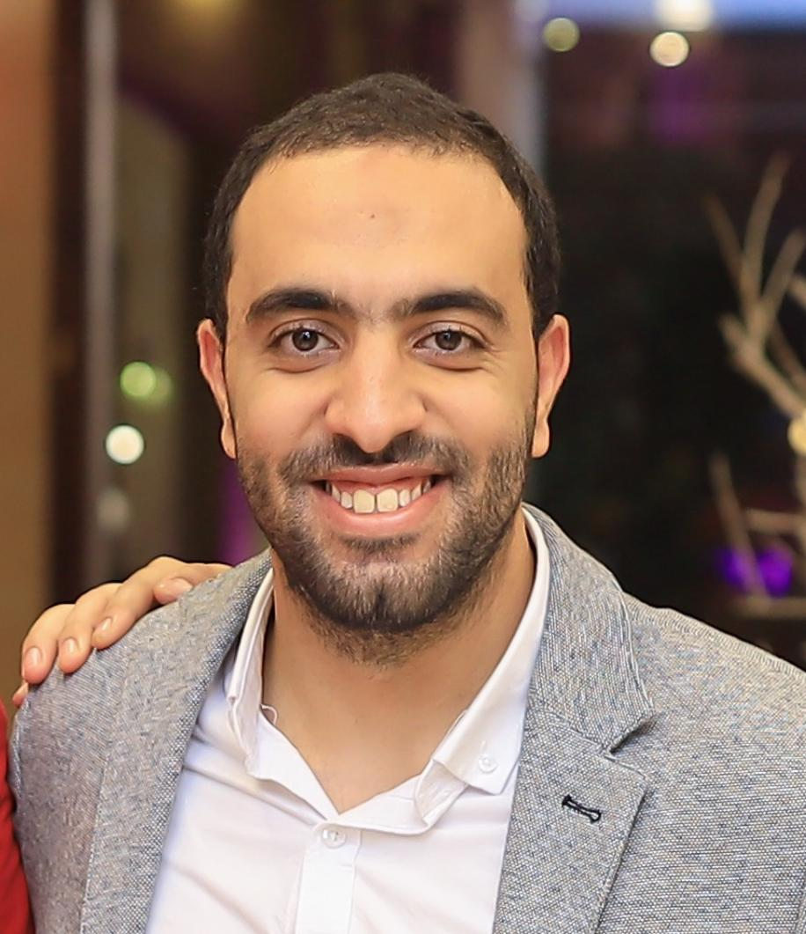

Education and Degree obtained

Dates  Title of qualification awarded  Name and type of organisation | 2022  Master degree (M.Sc.), General Surgery  Faculty of Medicine, Banha University, Egypt
Dates  Title of qualification awarded  Name and type of organisation | 2017  B.Sc. Medicine and Surgery (M.B.B.Ch)  Faculty of Medicine, Banha University, Egypt

Personal skills and competences
Languages | Arabic (Mother tongue), English (Proficient), French (Basic)
Computer skills | Familiar with :  - MS Windows 7, 10.  - MS office Power point, Access, Excel and Word
Social skills and competences | - Good ability to adapt to multicultural environments, gained through my work experience.  - Team spirit

Courses and certificates
- Fundamentals of Digital Transformation Certificate (FDTC)
- BU TOEFL test with score 543

Work experience
Dates  Occupation or position held  Name and address of employer | March 2018 → February 2019  House officer  Banha University Hospitals, Banha, Egypt
Dates  Occupation or position held  Name and address of employer | April 2019 → June 2019  General Practitioner  Ministry of Health, Egypt
Dates  Occupation or position held  Name and address of employer | June 2019 → July 2022  Resident of General surgery  Department of general surgery , Faculty Of Medicine, Banha University, Egypt
 |  | www.fmed.bu.edu.eg
Dates  Occupation or position held  Name and address of employer | August 2022 → October 2022  Resident of General surgery  Ministry of Health, Egypt
Dates  Occupation or position held  Name and address of employer | October 2022 → till now  Teaching assistant of General surgery  Department of general surgery , Faculty Of Medicine, Banha University, Egypt
 |  | www.fmed.bu.edu.eg

